Project Development Phase
Model Performance Test

Date | 08/10/2026
Team ID | SWTID-2026-3272
Project Name | Implement Client Script and UI Policy (Incident) – ServiceNow
Maximum Marks

Model Performance Testing:
Project team shall fill the following information in model performance testing template.
S.No. | Parameter | Values | Screenshot
 | Implementation Summary | Platform: ServiceNow (Incident table).  UI Policies (3): Hold reason visible and mandatory when State = On Hold; Close code and Close notes visible and mandatory when State = Resolved / Closed; non-relevant fields hidden and Caller read-only after save. "Reverse if false" and "Run scripts" enabled.  Client Scripts (4): onLoad – info message for Priority 1 incidents; onChange (Category) – clear Subcategory and show a field message; onChange (Impact / Urgency) – confirm Priority recalculation; onSubmit – block save if Short description is under 10 characters. | 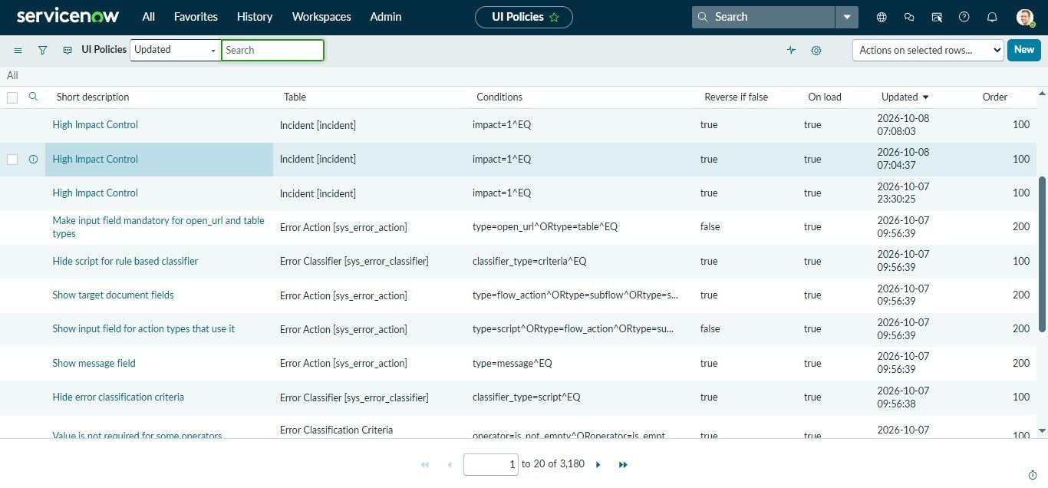  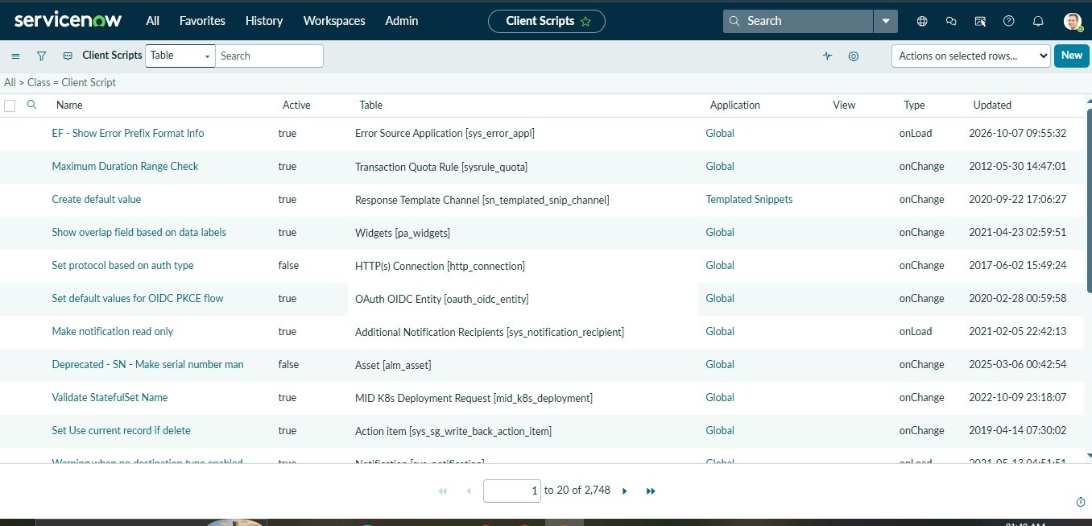  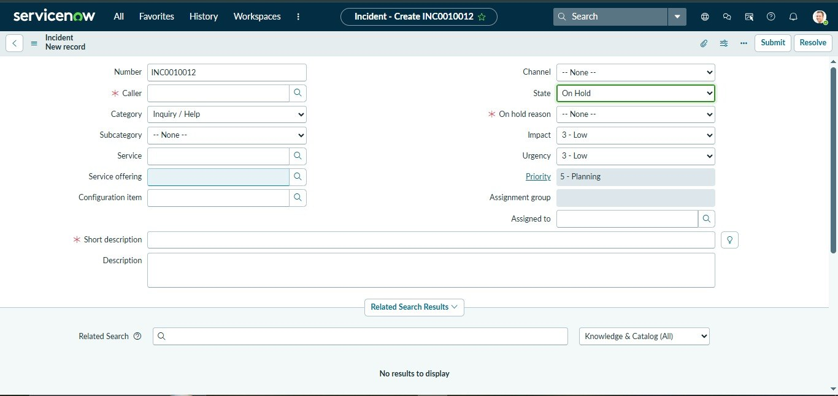
 | Accuracy (Test Case Pass Rate) | UI Policy Test Pass Rate – 6 test cases (State, Category and field conditions). Expected result: 6 / 6 passed (100%).  Client Script Test Pass Rate – 6 test cases (onLoad, onChange, onSubmit). Expected result: 6 / 6 passed (100%). | 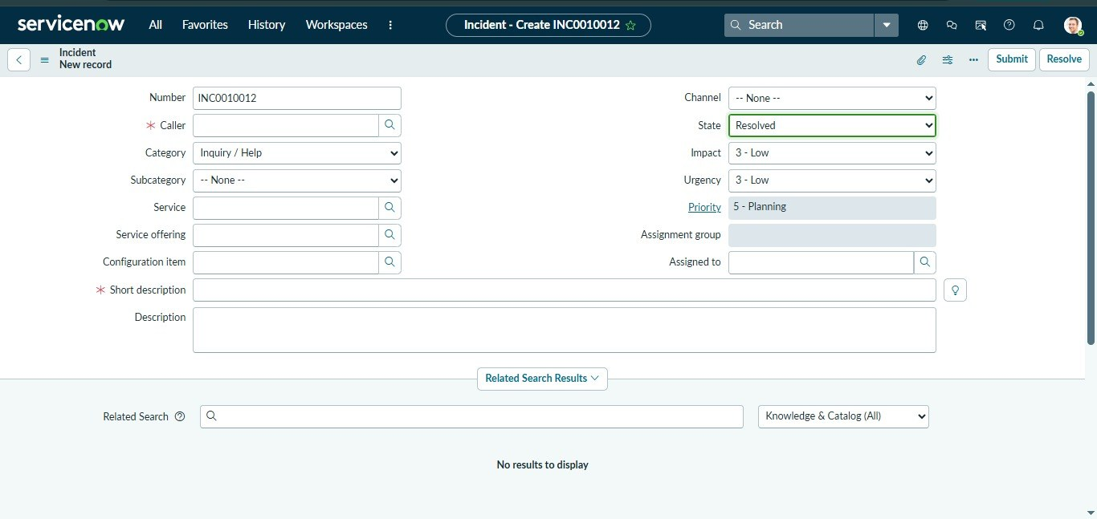  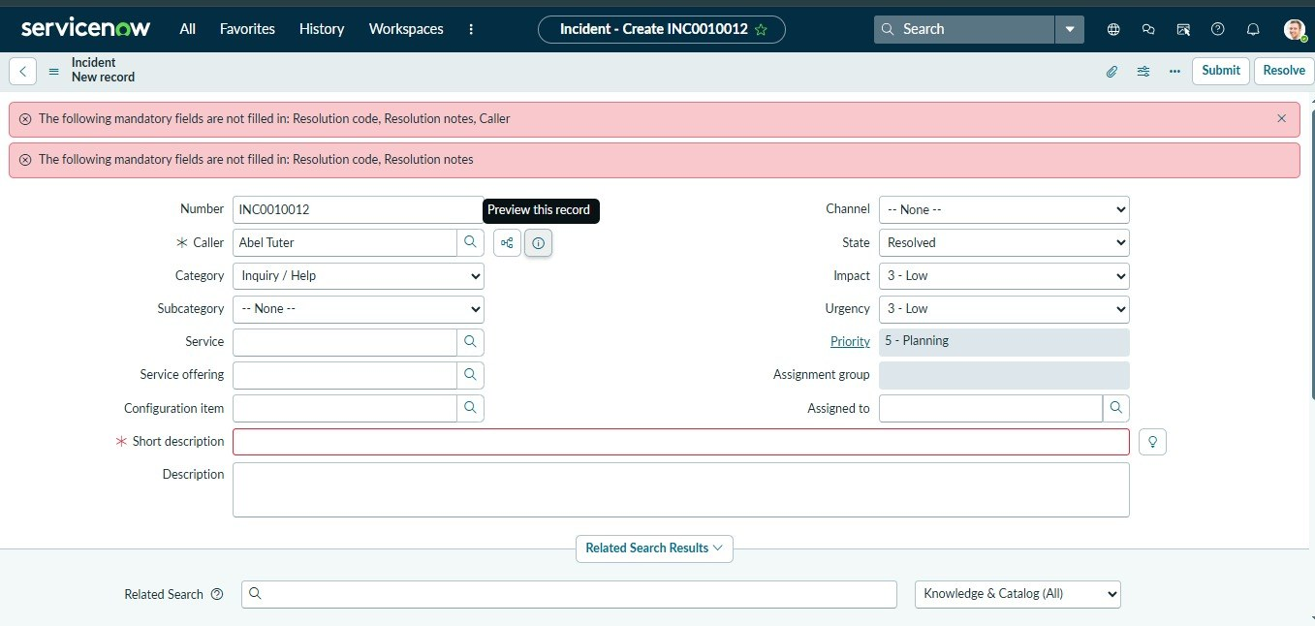
3. | Fine Tuning Result (if done) | Refinements after testing: enabled "Reverse if false" so fields return to normal; tuned the Short description length check to 10 characters; set UI Policy order so conditions do not conflict.  Re-test Pass Rate (after fine tuning) – 12 test cases. Expected result: 12 / 12 passed (100%). | 